
Department of Computer Science

University of Gujrat

SILENCE IS HEARABLE

Submitted By:

Ayesha Zulfiqar | 20021519-023
Maham Hanif  Noor Ul Ain | 20021519-056  20021519-069

Supervised By:
Dr. Zafar Mehmood Khattak

DECLARATION

I certify that “Silence is Hearable” is under my supervision with students Ayesha Zulfiqar (20021519-023), Maham Hanif (20021519-056), & Noor Ul Ain (20021519-069) of the Computer Science (CS) Department, Faculty of Computing & Information Technology, University of Gujrat, Pakistan, worked under my supervision.

__________________________________
Dr. Zafar Mehmood Khattak
Department of Computer Science
Faculty of Computing & Information Technology
University of Gujrat, Punjab, Pakistan.
Email: zafar.mehmood@uog.edu.pk

Dated: August 09, 2023.

Final Year Project Proposal

Abstract
In this Big Universe, there are billions of people who are created by Allah Almighty and The Almighty has blessed all his creation with his blessings. These blessings include the sense of hearing, and speaking but there are some special people out there who do not have these blessings of listening and speaking due to which they can’t communicate like normal people.

Due to their inability to speak or hear they can communicate using sign language. Sign Language is a form of communication that uses hand movements, facial expressions, body postures, and other movements to speak to other people.

There are many existing devices that are designed to help such people to communicate with each other, but these devices are costly and aren’t affordable by everyone. In this project, we are going to design a Sign Language Detection System using American Sign Language (ASL) that will be easily accessible by such people. It is an innovative communication technology designed to facilitate seamless interaction for sign language users.

Introduction
Sign language is a rich and vital form of communication for individuals with hearing impairments. It serves as their primary means of expressing thoughts, ideas, and emotions. However, the gap between sign language and spoken language can sometimes limit effective communication between the hearing-impaired and the hearing community. To bridge this gap, technological advancements in the field of computer vision and machine learning have led to the development of Sign Language Recognition systems. These systems enable the real-time translation of sign language gestures into written or spoken language, facilitating better interaction, and understanding between individuals who use sign language and those who do not.

In this proposal, we outline a project that aims to develop a robust American Sign language detection system using deep learning algorithms. The proposed system comprises of the key module: Sign language detection using computer vision (Deep learning algorithms) with facial expression analysis.

The sign language detection system will be deployed in a Mobile App. The smartphone’s mobile app will use the embedded camera to detect and understand the user’s input of sign language expressions & will convert it into American English text which will be easily understandable by the listener.

The system will facilitate the deaf and mute people to communicate effectively and somehow overcome the disability of hearing and speaking. The system will primarily focus on detecting sign language gestures while detecting facial expressions to enhance accuracy and context understanding. The goal is to create a real-time application that can recognize sign language gestures and interpret their corresponding meanings.

Project Title:

Silence is Hearable

Project Overview statement:
The American Sign Language Detection with Facial Expressions using Deep Learning algorithms aims to revolutionize sign language communication by harnessing the power of deep learning algorithms. Through this innovative system, we aspire to foster a more inclusive and understanding society where individuals of all abilities can communicate effortlessly and connect on a deeper level.

Targeted Audience:
The primary audience for this project is the deaf and hard-of-hearing community. The sign language detection system will empower them to communicate more effectively.

Areas such as Schools and Educational Institutions catering to deaf and hard-of-hearing students can use the sign language detection system to support sign language learning, communication in classrooms, and interactive educational experiences.

Overall, the project's targeted audience is diverse, encompassing the deaf community, individuals, and organizations interested in accessibility, education, customer service, and technology developers who aim to make a positive impact on communication and inclusivity for all.

Project Goals & Objectives:
The project’s primary goal is to enhance communication accessibility for the deaf and hard-of-hearing community. The project aims to bridge the communication gap for sign language users by developing this system, making communication more inclusive and natural. The real-time sign language detection and translation features empower sign language users to interact and communicate effortlessly, fostering a more inclusive society.

- Gather a diverse and comprehensive dataset of hand gestures and facial expressions based on American Sign Language (ASL).
- Preprocess and annotate the data to ensure its quality and suitability for training deep learning models. Explore state-of-the-art algorithms like CNNs and RNNs to achieve high accuracy. Implement facial expression recognition algorithms to complement sign language detection.

Train the model to interpret facial expressions, providing context and emotional cues to enhance the communication experience.

Application Architecture:
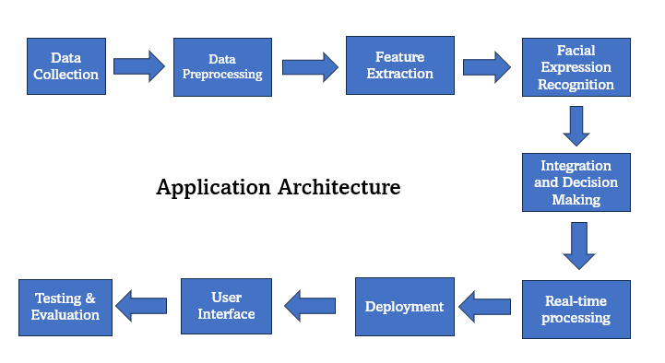
- Data Collection: Capturing facial images or videos, annotating facial expressions, and labeling signs.
- Data Preprocessing: Facial landmark detection, normalization of images, and data augmentation. Creating feature vectors from facial expressions.
- Feature Extraction: Capture relevant information from the input data that is essential for identifying and recognizing sign language gestures accurately using deep learning algorithms.
- Facial Expression Recognition: Analyzing the facial expressions using deep learning algorithms of the signer to determine their emotions.
- Integration & Decision Making: Different components of the system are brought together and the final output or decision is made based on the input data.
- Real-time processing: Provide immediate feedback or responses to users who are using sign language as a means of communication.
- Deployment: Making the developed sign language detection system or application available and accessible for use by end-users or clients.
- User-Interface: Provide a user-friendly and intuitive way for users to input their sign language gestures and receive feedback or results from the system.
- Testing and Evaluation: Ensure the accuracy and reliability of the system.

Hardware and Software Specification:
- Hardware Specifications:
- Camera or video-input device: A camera or video-input device to capture the user's sign language gestures. The camera should have sufficient resolution and frame rate to ensure accurate and smooth gesture recognition.
- Processing Unit: For real-time applications, a powerful processor is required to handle the image processing, feature extraction, and gesture recognition tasks. Modern CPUs with multiple cores and high clock speeds are beneficial.
- Memory (RAM): 8 GB
- Storage: Depending on the project's requirements, adequate storage capacity might be needed to store the dataset, preprocessed data, trained models, and other resources.
- Software Specifications:
- Operating System: Android 7+ and iOS 10+
- Programming Languages: Depending on the specific tasks and technologies used, expertise in one or more programming languages will be required.
- Libraries and Frameworks: Various libraries and frameworks are available to simplify the development of sign language detection projects.

Tools and technologies used with reasoning:
- Jupyter Notebook: Will be used as IDE.
- Android Studio: Will be used as IDE for developing Android applications.
- Dart & Python: Programming Languages.
- Flutter: For making cross-platform mobile applications that will act as an interface.
- TensorFlow & TensorFlow Lite: A tool that will be used to train our model, using deep learning and CNN.
- OpenCV: Used for image & video preprocessing.
- Keras: A high-level neural network library that runs on top of TensorFlow to train models.
- Convolutional Neural Network – CNN: The tool is used for the extraction of features from images.
- Recurrent Neural Network – RNN: Designed to handle sequential & temporal data making them suitable for tasks involving sequences like text and speech.
- Python: Python to create a backend in Flask and for modal training

Project milestones and deliverables
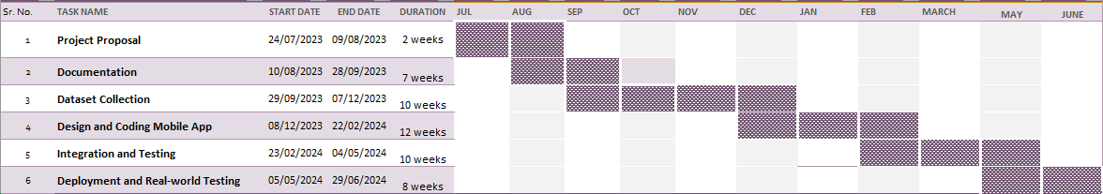

Work division among Group members
The work division along the group members is assigned as follows:
Tasks | Dataset Collection | Categorizing the dataset | Implementing the Models & Algorithms | Mobile App Development
Group Members | By All | Noor Ul Ain & Maham Hanif | Ayesha Zulfiqar | By All

